# CS 255 System Design Document Template

This template lays out all the different sections that you need to complete for Project Two. Each section has guidance to prompt your thinking. You will need to continually reference the interview transcript as you work to make sure that you are addressing your client’s needs. There is no required length for the final document. Instead the goal is to complete each section based on what your client’s needs are. Remove this note when you are finished, and replace all bracketed text with the relevant information.

## UML Diagrams

### UML Use Case Diagram

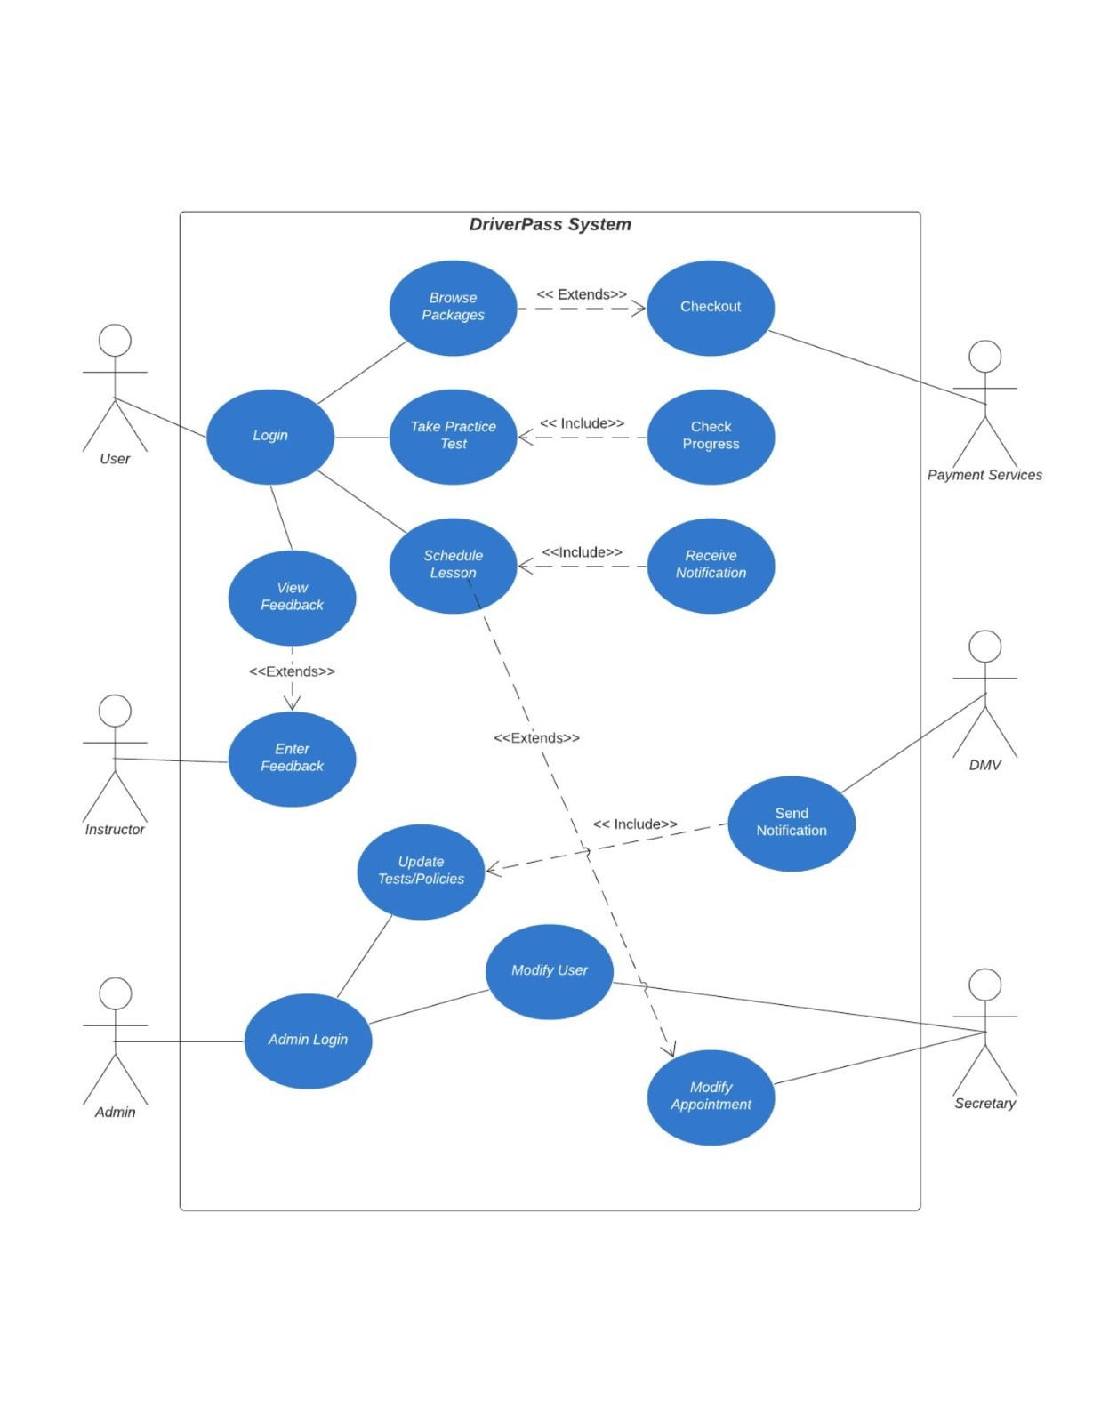

### UML Activity Diagrams

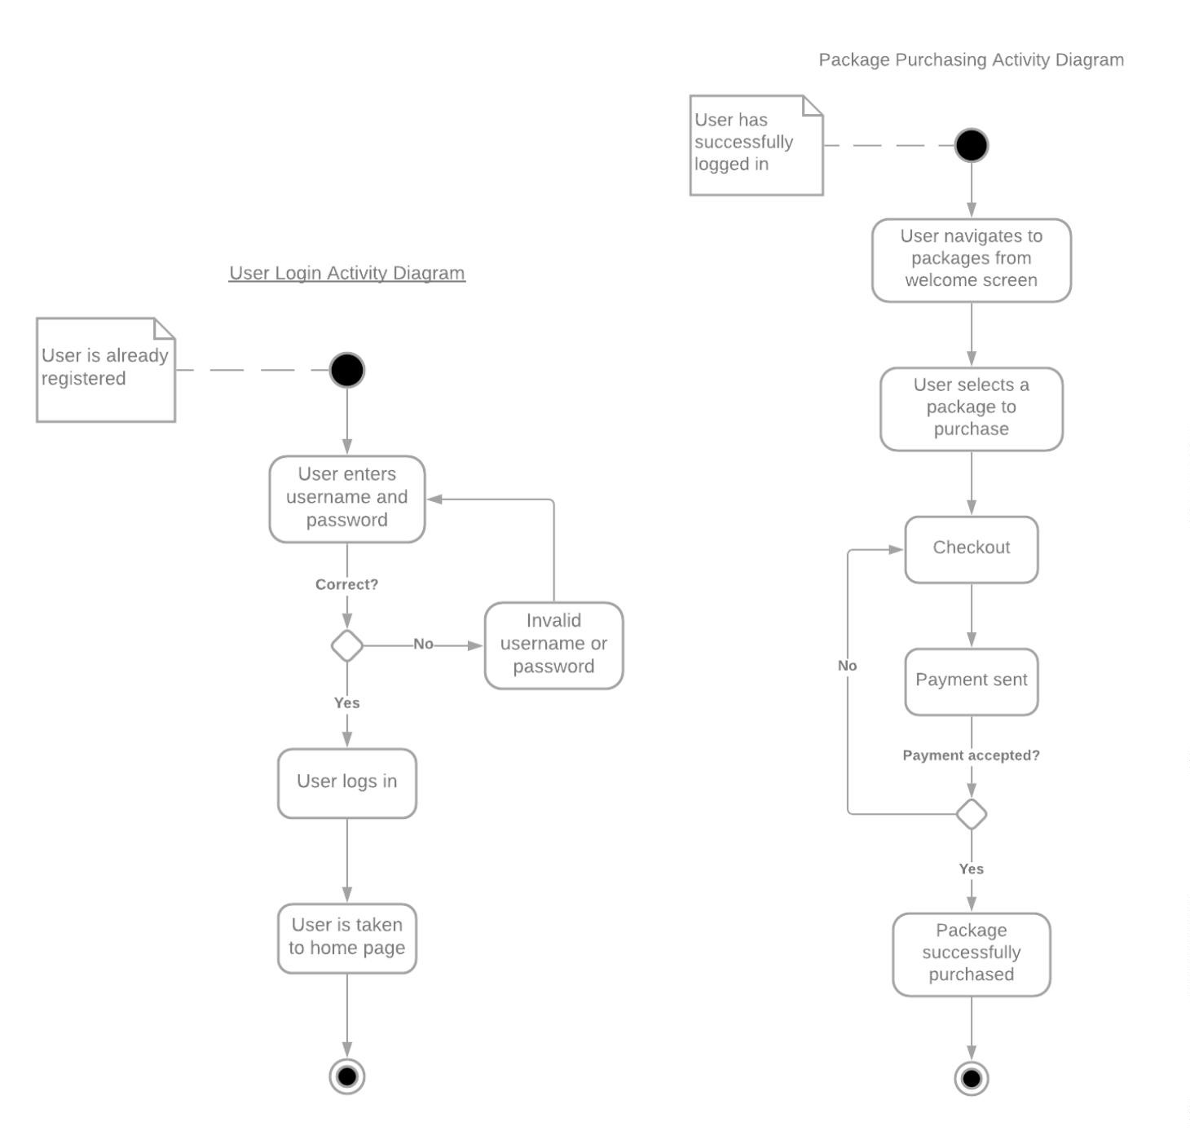

### UML Sequence Diagram

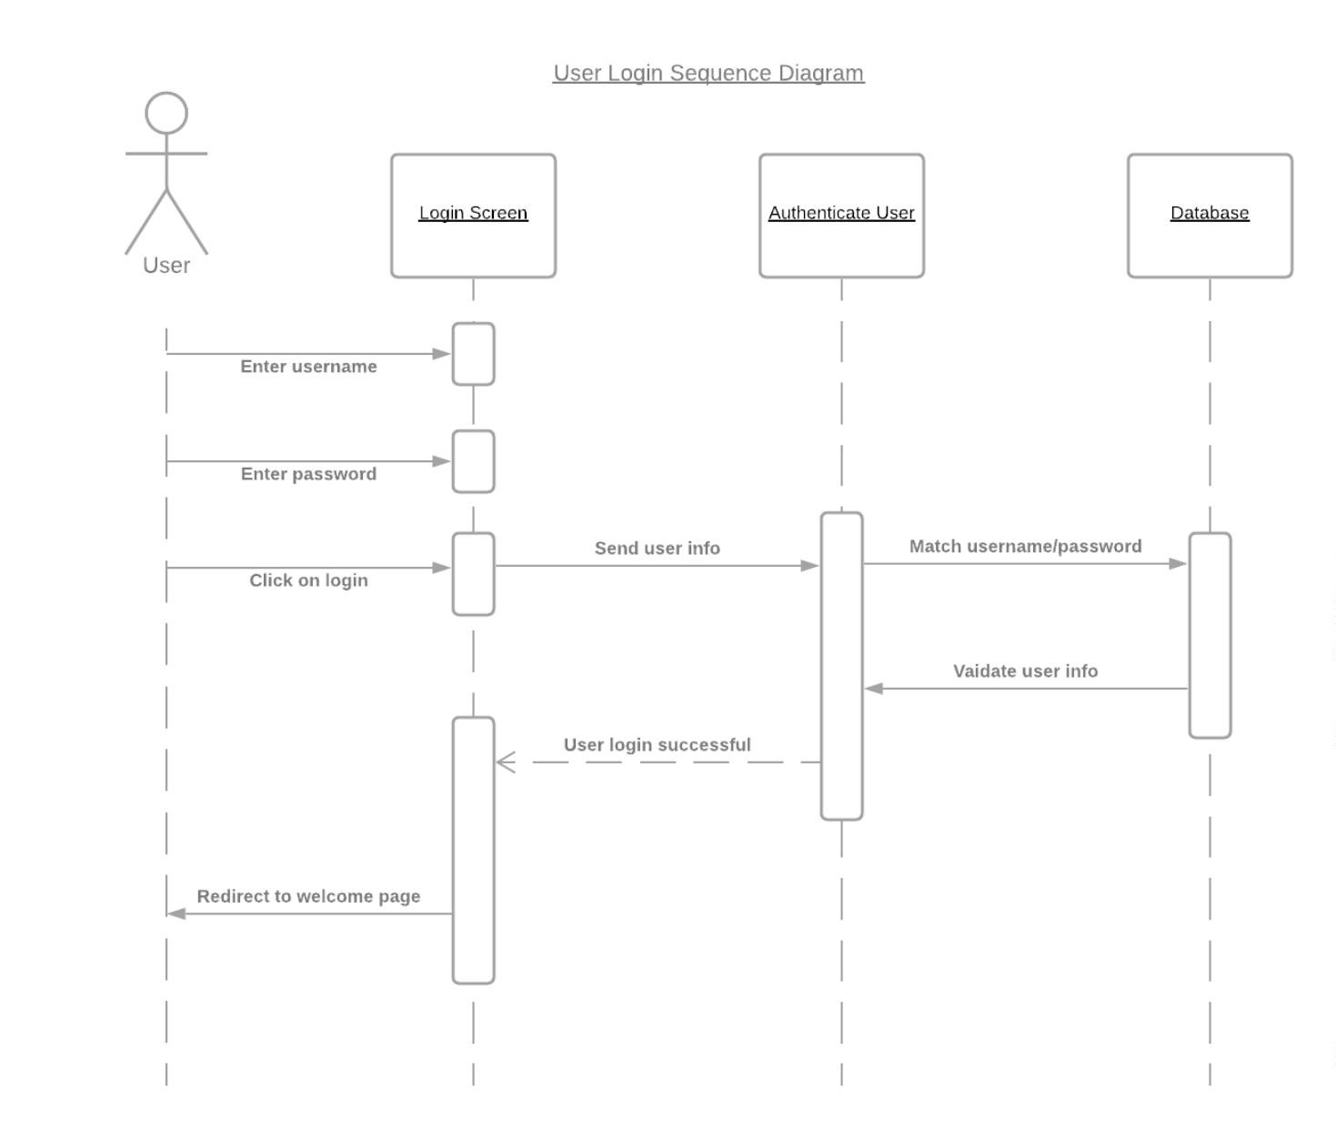

### UML Class Diagram

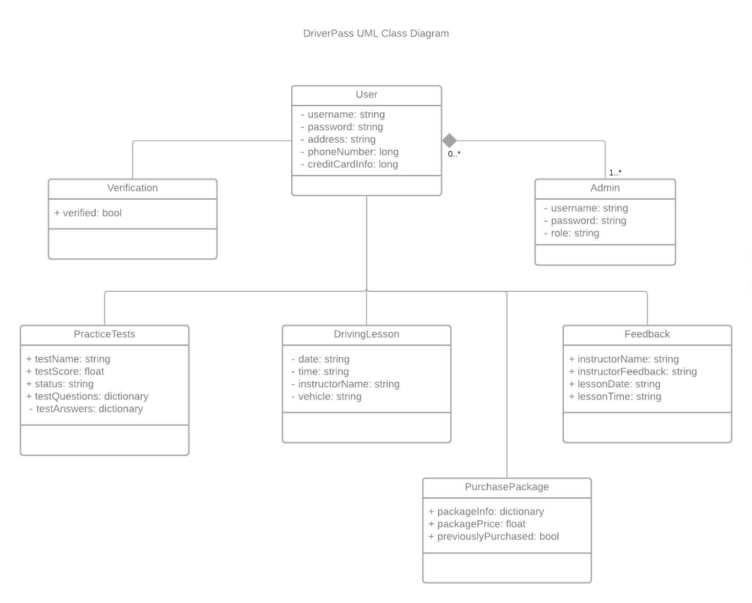

## Technical Requirements

The DriverPass system shall be a web-based application developed using the Java language and deployed using a cloud-based hosting service. The hosting service will house the database for user account information, the server code, past appointment information, and the main Java code.